Copyright reserved

Please turn over

**NATIONAL CERTIFICATE**

**INDUSTRIAL INSTRUMENTS N5**

**12**

**APRIL 2018**

**This marking guideline consists of 8 pages.**



**MARKING GUIDELINE**

**SECTION A: FLOW MEASUREMENTS**

# QUESTION 1

1.1 C 1.2 D 1.3 D 1.4 B 1.5 C 1.6 A 1.7 C

1.8 B

(8 × 1) **[8]**

# QUESTION 2

2.1

2.1.1

BLUFF

BODY

VELOCITY INCREASE

PRESSURE

DECREASE

FLOW

VELOCITY DECREASE

PRESSURE INCREASE

(6)

2.1.2 • Liquid suspension

* Steam measurements
* Natural gas measurement
* Liquid chemicals (Any 3 × 1) (3)

2.2 2.2.1 A - Heater

1. - Flow
2. - Temperature sensor
3. - Temperature sensor (4)

2.2.2 Externally heated tube/External elements and heater (2)

-3-

PRODUCTION AND QUALITY CONTROL N5

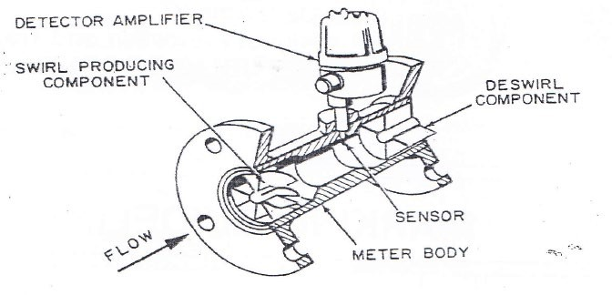2.3 2.3.1

**OR**

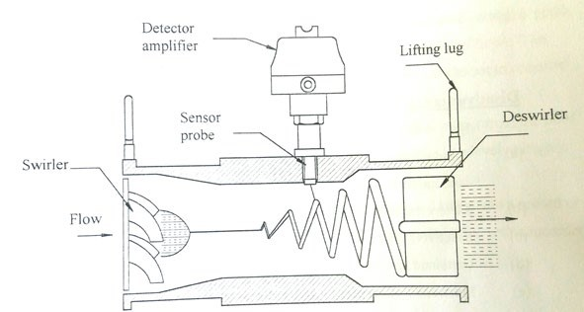

(6)

2.3.2 Advantages

* No moving parts
* Low-pressure losses
* High accuracy

Disadvantages

* Expensive
* In-mounting requirement

|  |  |
| --- | --- |
| • Not accurate in slurry application (3 + 3) | (6) |
|  | **[27]** |
| **TOTAL SECTION A:**      **SECTION B: DENSITY, HUMIDITY AND VISCOSITY MEASUREMENT**    **QUESTION 3** | **35** |

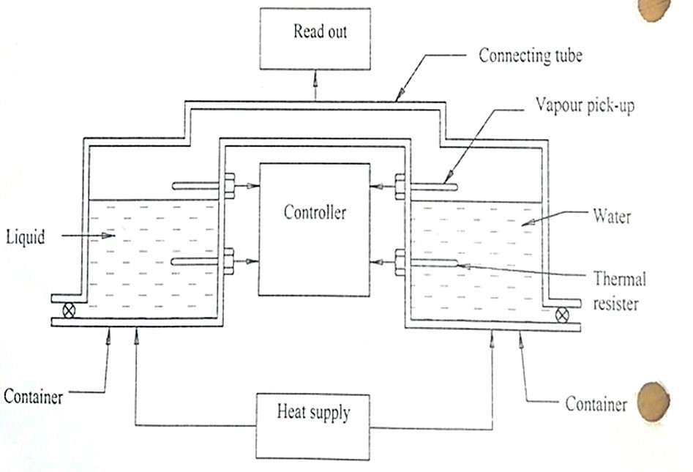3.1

|  |  |
| --- | --- |
| * Liquid and water must be boiled.✓ * When liquid and water starts to boil, vapour will be formed.✓ * This vapour will be picked up and sent to the controller to record the temperature measured with a thermal resister.✓ * If the temperature of the liquid at boiling point differs from the boiling point of the water, the difference in temperature will be directly proportional to the density of the liquid.✓ * The pressure of both containers is kept constant with a connecting tube connecting the container.✓ | (10) |

3.2 Detector

Interference filters

Reflecting mirror

Moving sample

meter

Amp

Infra red

source

√

√

√

√

√

√

Concave lens

* The instrument consists of a light source, filters to separate the measuring and reference wave lengths, lenses to concentrate the beam on the sample and a concave mirror to reflect the beam onto a photocell.✓
* The reference filter will measure a specific wavelength and will be compared with a measured wavelength obtained from the measuring lens.✓
* These wavelengths will be picked up by the photocell and induce two current pulses.✓
* The relation between the two signals will be a function of the vapour

present on the surface of the sample.✓ (10)

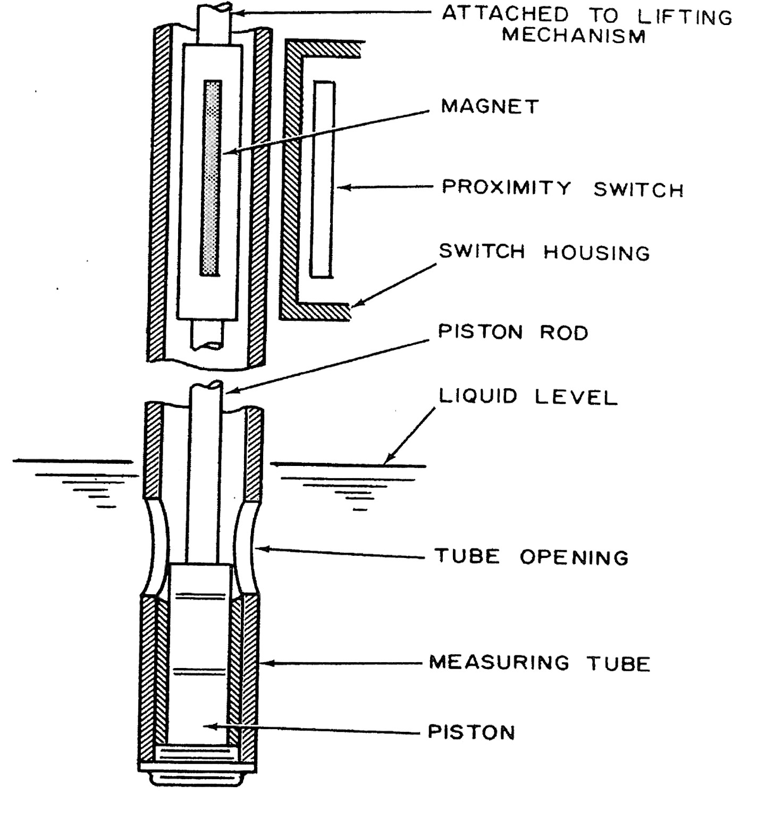3.3

(9)

**[29]**

**TOTAL SECTION B: 29**

**SECTION C: pH MEASUREMENT**

# QUESTION 4

4.1 pH1 = log( 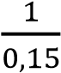) = 0,824✓

pH2 = log(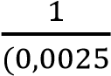) = 2,6✓

Change in pH = 0,824 – 2,6✓

= -1,776✓ (4)

4.2 4.2.1 A conductivity cell constant is a function of the area of the electrodes,✓ the distance between the electrodes✓ and the electric

field pattern between the electrodes.✓ (3)

|  |  |  |
| --- | --- | --- |
| 4.2.2 | The electrodes acquire a certain surface potential✓ due to loss or gain of electrons✓ when an electric current is passed between |  |
|  | electrodes in a solution of electrolysis.✓ | (3) |

(5)

4.3

mV

+

+

mV

mV

-

-

mV

0

0

T1(°F)

T1(°F)

T1(°F)

T1(°F)

T2(°F)

T2(°F)

T2(°F)

T2(°F)

Iso potential point

7

7

14

14

pH values

pH values

(5

)

|  |  |
| --- | --- |
|  | **[20]** |
| **TOTAL SECTION C:** | **20** |

**SECTION D: AUTOMATIC CONTROL**

# QUESTION 5

5.1 5.1.1 • All four bellows will have the same pressure.

* The motion pin will be on its true centre line.
* No control actions will be generated. (3)

5.1.2 • The output will increase by ±10 kPa if the gain is direct or decrease by ±10 kPa should the gain be indirect.✓

* This would be due to a pressure increase in the process bellows while the pressure in the other bellows stays constant.✓
* The motion pin will move off its centre line causing the flapper to move either towards or away from the nozzle.✓
* This should cause the nozzle feedback pressure to either increase or decrease, thus causing the output to change

accordingly.✓ (4)

5.1.3 100 100

𝑃𝑃𝑃𝑃 = = = 100✓ (1)

gain 1,0

5.1.4 By swivelling the gain adjustment dial from direct to reverse (1)

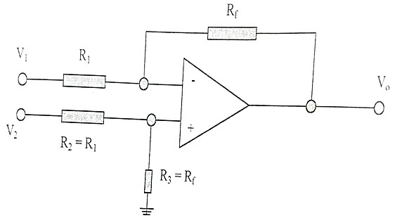5.2

(4)

5.3 • Wheatstone bridge

* Linear variable differential transformer
* Linear variable capacitive transducer (3)

# [16]

**TOTAL SECTION D: 16**

**GRAND TOTAL: 100**